**Speech to Text**

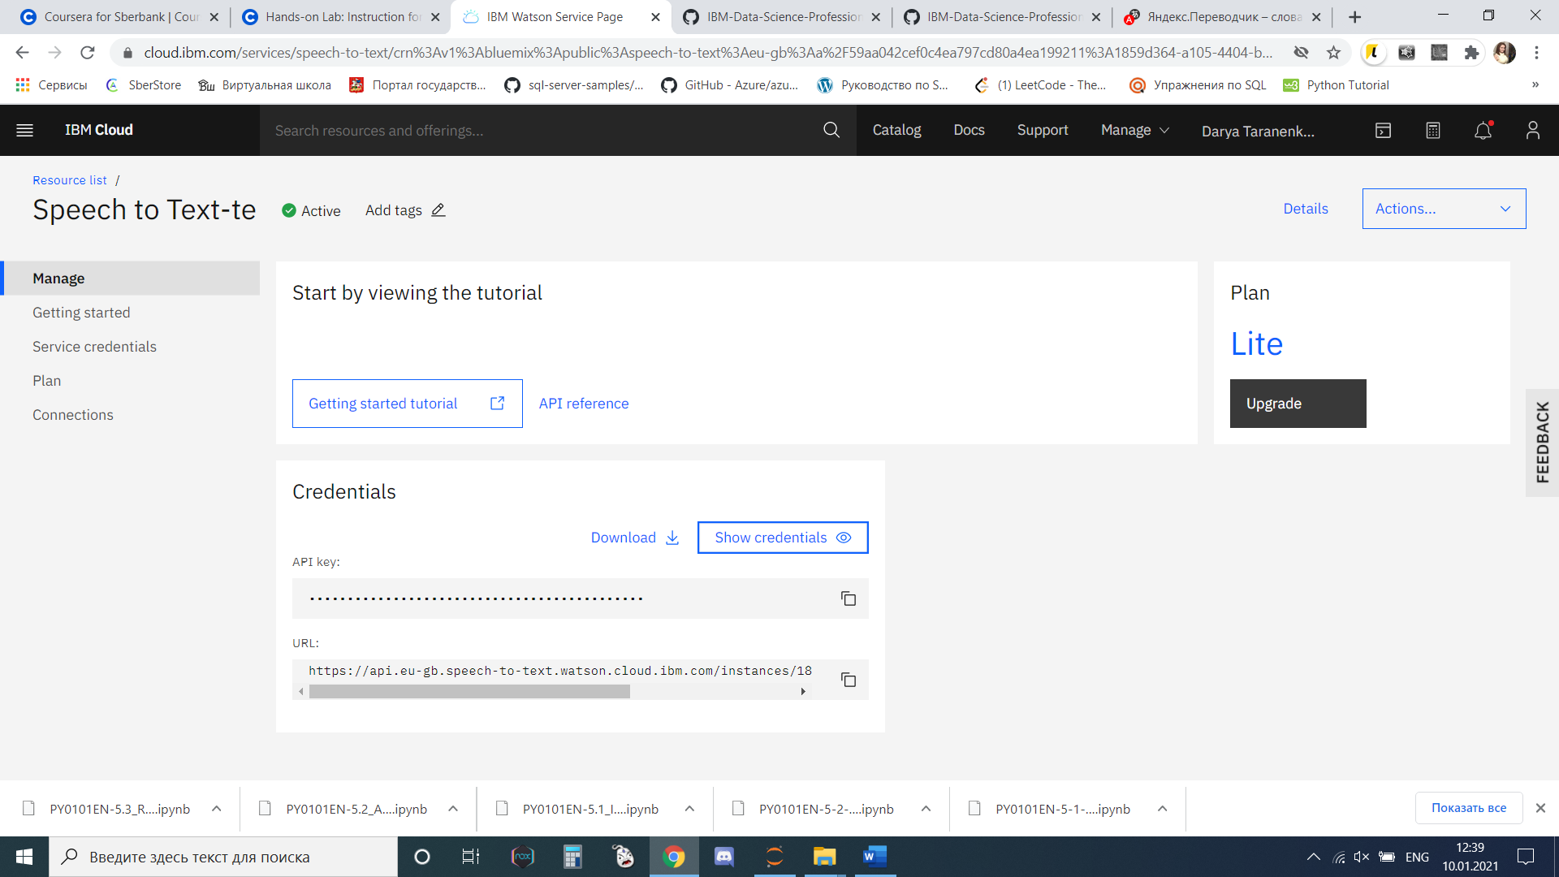

<https://cloud.ibm.com/services/speech-to-text>

**Language Translator**

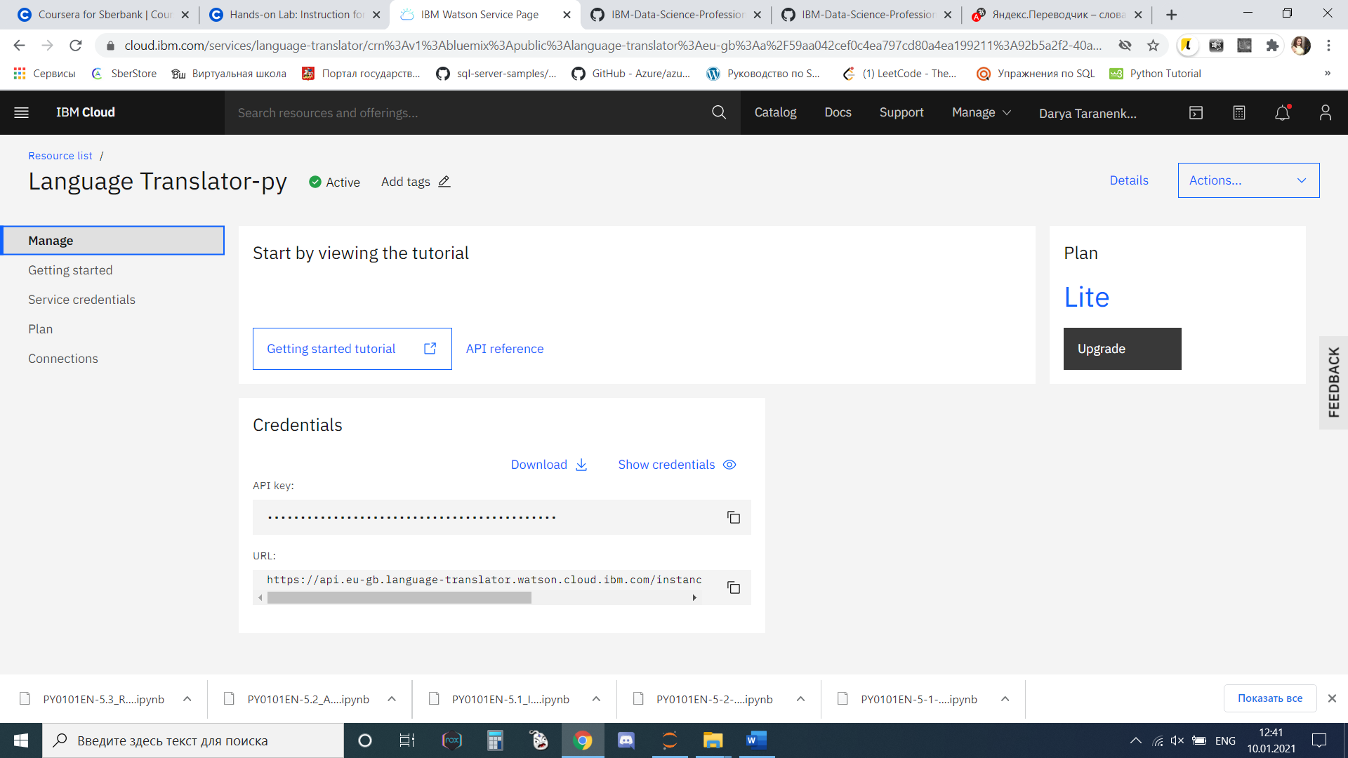

<https://cloud.ibm.com/services/language-translator>